# How to Get Schema Information from Database

## Introduction

Sometimes we may need the schema information of the database, tables or some columns. In this application, we will demonstrate how to get schema information from database:

1. In this application, we will use the SqlConnection.GetSchema Method.

2. We will use the Schema Restrictions to get the specified information.

3. We will get the schema information of the database, tables, some columns and so on.

## Building the Sample

Before you run the sample, you need to finish the following steps:

Step1. Please choose one way of the following ways to build the database:

• Attach the database file MySchool.mdf under the folder _External_Dependecies to your SQL Server 2008 database instance.

• Run the MySchool.sql script under the folder _External_Dependecies in your SQL Server 2008 database instance.

Step2. Modify the connection string in the Project Properties->Settings according-> MySchoolConnectionString to your SQL Server 2008 database instance name.

## Running the Sample

Press F5 to run the sample.

First, you can view the metadata of all the supported schema collections.

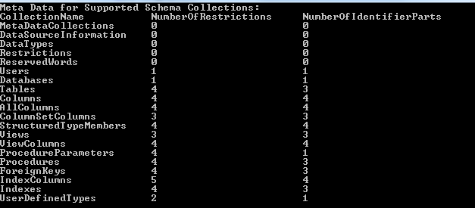

Then you can get the schema information of databases in your instance.

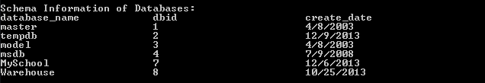

You can get the schema information of tables in a certain database.

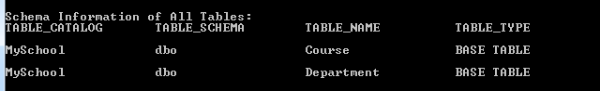

You can also get the schema information of a specified table.

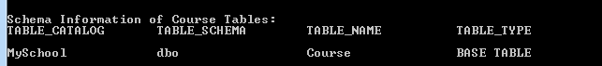

Beside specify the table name, you can also specify the table catalog, table schema, table type to get the schema information of the specified tables.

Like the tables mentioned above, you can get the columns or the specified column

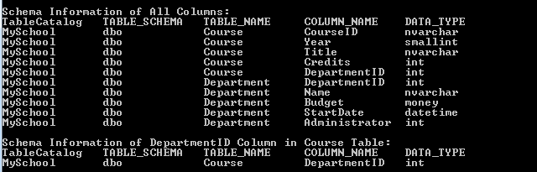

and get the index columns or the specified index column.

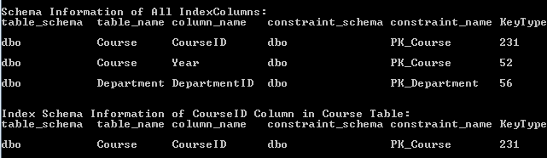

## Using the Code

a. Get the Meta Data for Supported Schema Collections

|  |
| --- |
| -Code block start-  --C# code snippet start--  DataTable metaDataTable = conn.GetSchema("MetaDataCollections");  --C# code snippet end--  --VB code snippet start--  Dim metaDataTable As DataTable = conn.GetSchema("MetaDataCollections")  --VB code snippet end--  -Code block end- |

You can also directly use the conn.GetSchema() method.

b. Get the schema information of Databases in your instance

|  |
| --- |
| -Code block start-  --C# code snippet start--  DataTable databasesSchemaTable = conn.GetSchema("Databases");  --C# code snippet end--  --VB code snippet start--  Dim databasesSchemaTable As DataTable = conn.GetSchema("Databases")  --VB code snippet end--  -Code block end- |

c. Get the schema information of Tables

You can get the schema information of the tables in the current database.

|  |
| --- |
| -Code block start-  --C# code snippet start--  DataTable allTablesSchemaTable = conn.GetSchema("Tables");  --C# code snippet end--  --VB code snippet start--  Dim allTablesSchemaTable As DataTable = conn.GetSchema("Tables")  --VB code snippet end--  -Code block end- |

You can also specify the table catalog, table schema, table name, table type to get the specified table(s).

|  |
| --- |
| -Code block start-  --C# code snippet start--  String[] tableRestrictions = new String[4];  tableRestrictions[2] = "Course";  DataTable courseTableSchemaTable = conn.GetSchema("Tables", tableRestrictions);  --C# code snippet end--  --VB code snippet start--  Dim tableRestrictions(3) As String  tableRestrictions(2) = "Course"  Dim courseTableSchemaTable As DataTable = conn.GetSchema("Tables", tableRestrictions)  --VB code snippet end--  -Code block end- |

## More Information

[Schema Restrictions](http://msdn.microsoft.com/en-us/library/cc716722(VS.110).aspx)

[SQL Server Schema Collections](http://msdn.microsoft.com/en-us/library/ms254969(VS.110).aspx)

[SqlConnection.GetSchema Method (String, String[]](http://msdn.microsoft.com/en-us/library/ms136367(VS.110).aspx))